https://www.nlog.nl/nlog-mapviewer/brh/594930591?lang=nl
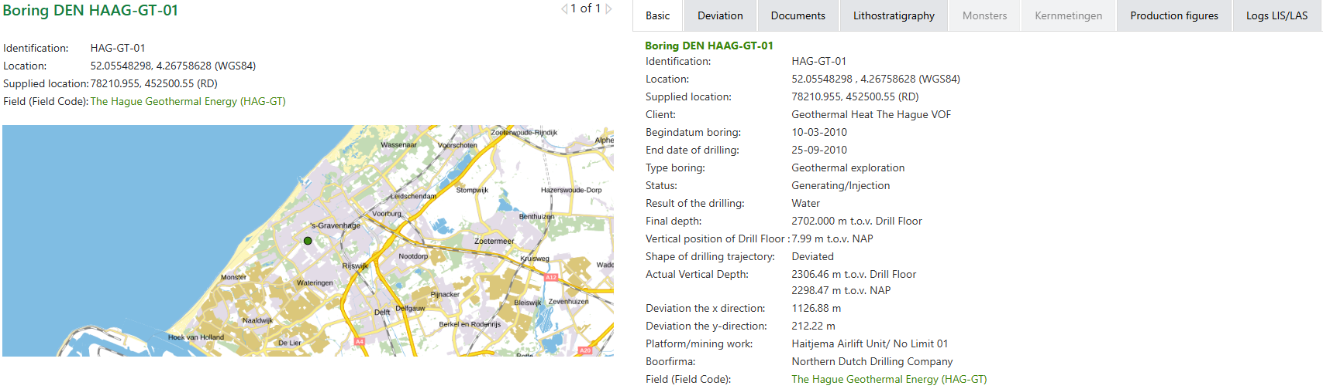

Boring DEN HAAG-GT-01
Category | Document
Borehole/Well - Final Report | End of well report HAG GT 01(11 Feb 2011)  Geological Well Report(25 Sep 2010) # 1  Geological Well Report(25 Sep 2010) # 2  Geological Well Report(25 Sep 2010) # 3  Geological Well Report(25 Sep 2010) # 4  Geological Well Report(25 Sep 2010) # 5  Geological Well Report(25 Sep 2010) # 6  Geological Well Report(25 Sep 2010) # 7  SODM Final Report(06 Nov 2010)
Documents with borehole measurements | Lithology Log(25 Sep 2010)  Sperry Drilling Recorded LWD data - Field copy(13 Sep 2010)
Documents with test result borehole | ADH Clean-up - Test Formulier 120319 t/m 120326(01 Jun 2012) # 1  ADH Clean-up - Test Formulier 120319 t/m 120326(01 Jun 2012) # 2  Pressure/Temperature vs Time - Water and Gas(04 Nov 2010)  Production test(19 Sep 2010)  Well Testing Report HAG-GT-01 (Producer)(18 Oct 2010)
Borehole sample research reports | Analysis Report Water/Gas Samples(11 Aug 2011)  DEVLI project: Stratigraphy and tectonostratigraphy of the Delfland and Vlieland subgroups, Upper Jurassic and Lower Cretaceous - Broad Fourteens Basin, West Netherlands Basin and neighbouring areas. (20 Nov 2024)  Sandstone description(25 Sep 2011)

